23

SIX DEBATES OVER MACROECONOMIC POLICY

WHAT’S NEW IN THE SEVENTH EDITION:

Two new In the News features have been added on “How long will the Fed keep interest rates at zero?” and "What would an American fiscal crisis look like?"

LEARNING OBJECTIVES:

By the end of this chapter, students should understand:

➢ the debate concerning whether policymakers should try to stabilize the economy.

- the debate concerning whether the government should fight recessions with spending hikes or tax cuts.

- the debate concerning whether monetary policy should be made by rule rather than by discretion.

➢ the debate concerning whether the central bank should aim for zero inflation.

➢ the debate concerning whether the government should balance its budget.

➢ the debate concerning whether the tax laws should be reformed to encourage saving.

CONTEXT AND PURPOSE:

Chapter 23 is the final chapter in the text. It addresses six unresolved issues in macroeconomics, each of which is central to current political debates. The chapter can be studied all at once, or portions of the chapter can be studied in conjunction with prior chapters that deal with the related material.
The purpose of Chapter 23 is to provide both sides of six leading debates over macroeconomic policy. It employs information and tools that students have accumulated in their study of this text. This chapter may help students take a position on the issues addressed or, at least, it may help them understand the reasoning of others who have taken a position.

KEY POINTS:

• Advocates of active monetary and fiscal policy view the economy as inherently unstable and believe that policy can manage aggregate demand in order to offset the inherent instability. Critics of active monetary and fiscal policy emphasize that policy affects the economy with a lag and that our ability to forecast future economic conditions is poor. As a result, attempts to stabilize the economy can end up being destabilizing.

- Advocates of increased government spending to fight recessions argue that because tax cuts may be saved rather than spent, direct government spending does more to increase aggregate demand, which is key to promoting production and employment. Critics of spending hikes argue that tax cuts can expand both aggregate demand and aggregate supply and that hasty increases in government spending may lead to wasteful public projects.

• Advocates of rules for monetary policy argue that discretionary policy can suffer from incompetence, abuse of power, and time inconsistency. Critics of rules for monetary policy argue that discretionary policy is more flexible in responding to changing economic circumstances.

• Advocates of a zero-inflation target emphasize that inflation has many costs and few if any benefits. Moreover, the cost of eliminating inflation—depressed output and employment―is only temporary. Even this cost can be reduced if the central bank announces a credible plan to reduce inflation, thereby directly lowering expectations of inflation. Critics of a zero-inflation target claim that moderate inflation imposes only small costs on society, whereas the recession necessary to reduce the inflation is quite costly. The critics also point out several ways in which moderate inflation may be helpful to an economy.

• Advocates of a balanced government budget argue that budget deficits impose an unjustifiable burden on future generations by raising their taxes and lowering their incomes. Critics of a balanced government budget argue that the deficit is only one small piece of fiscal policy. Single-minded concern about the budget deficit can obscure the many ways in which policy, including various spending programs, affects different generations.

• Advocates of tax incentives for saving point out that our society discourages saving in many ways, such as by heavily taxing capital income and by reducing benefits for those who have accumulated wealth. They endorse reforming the tax laws to encourage saving, perhaps by switching from an income tax to a consumption tax. Critics of tax incentives for saving argue that many proposed changes to stimulate saving would primarily benefit the wealthy, who do not need a tax break. They also argue that such changes might have only a small effect on private saving. Raising public saving by decreasing the government’s budget deficit would provide a more direct and equitable way to increase national saving.

CHAPTER OUTLINE:
Provide supporting facts and figures for each side of the debates. Emphasize that there are no clear right or wrong answers. Do not forget to mention the political dimensions involved with these debates. At the heart of these debates is that there is a great deal of wealth and power at stake, and these considerations often are more important than the consensus of economists.


Instead of lecturing, divide the students into groups and have them present the debates discussed in the chapter. Ask them to provide facts and figures to support their positions.

I. Should Monetary and Fiscal Policymakers Try to Stabilize the Economy?

A. Pro: Policymakers Should Try to Stabilize the Economy

1. When households and firms feel pessimistic, aggregate demand falls. This causes output to fall and unemployment to rise.

2. There is no reason for the economy to suffer through a recession when policymakers can reduce the severity of economic fluctuations.

3. Thus, policymakers should take an active role in leading the economy to stability.

4. When aggregate demand is inadequate to ensure full employment, policymakers should act to boost spending in the economy. When aggregate demand is excessive and there is a risk of inflation, policymakers should act to reduce spending.

5. Such policy actions put macroeconomic theory to its best use by leading to a more stable economy.

B. Con: Policymakers Should Not Try to Stabilize the Economy

1. There are substantial difficulties associated with running fiscal and monetary policy. One of the most important problems to remember is the time lag that often occurs with policy.

2. Economic conditions change over time. Thus, policy effects that occur with a lag may hit the economy at the wrong time, leading to a more unstable economy.

3. Therefore, policymakers should refrain from intervening and be content with “doing no harm.”

C. In the News: How long will the Fed keep interest rates at zero?

1. After the financial crisis of 2008-2009, the Federal Reserve reduced its target for the federal funds rate to about zero.

2. This article from The Wall Street Journal describes the Fed's communication about its current policy and the conditions under which it may change its policy.

II. Should the Government Fight Recessions with Spending Hikes Rather than Tax Cuts?

A. Pro: The Government Should Fight Recessions with Spending Hikes

1. Traditional Keynesian analysis indicates that increases in government spending are a more potent tool than cuts in taxes.

a. Tax cuts can lead to increases in spending and saving.

b. Increases in government spending raise spending directly.

2. Estimates from the Obama administration suggest that $1 of tax cuts raises GDP by $0.99, but a $1 increase in government spending raises GDP by $1.59.

B. Con: The Government Should Fight Recessions with Tax Cuts

1. Policymakers can target particular types of spending (such as investment) with the right tax incentives.

2. Tax cuts may also increase aggregate supply.

a. Reducing marginal tax rates may provide greater incentive to work.

b. Increases in aggregate supply that accompany an increase in aggregate demand will keep the price level more stable.

III. Should Monetary Policy Be Made by Rule Rather than by Discretion?

A. Pro: Monetary Policy Should Be Made by Rule

1. Discretionary monetary policy leads to two problems.

a. It does not limit incompetence and abuse of power. For example, a central banker may choose to create a political business cycle to help out a particular candidate.

b. It may lead to a greater amount of inflation than is desirable. Policymakers often renege on the actions that they promise. If individuals do not believe that the central bank will follow a low inflation policy, the short-run Phillips curve will shift, resulting in a less favorable trade-off between inflation and unemployment.

2. One way to avoid these problems is to force the central bank to follow a monetary rule. This rule could be flexible enough to allow for some information on the state of the economy.

B. Con: Monetary Policy Should Not Be Made by Rule

1. Discretionary monetary policy allows flexibility. This gives the Fed the ability to react to unforeseen situations quickly.

2. It is also unclear that Fed central bankers use policy to help political candidates. Often, the policy used is one that actually lowers the candidate’s popularity (such as during the Carter administration).

3. The Fed can gain the confidence of people by following through on its promises. If it promises to fight inflation and then runs policies that keep the growth of the money supply low, there is no reason why inflation expectations would be high. Thus, the economy can achieve low inflation without a policy rule. (This was shown to be the case in the United States in the 1990s.)

4. It would also be very difficult to specify a precise rule.

C. FYI: Inflation Targeting

1. Many central banks around the world have adopted explicit targets for inflation.

2. The Federal Reserve has not adopted a formal policy of inflation targeting.

IV. Should the Central Bank Aim for Zero Inflation?

A. Pro: The Central Bank Should Aim for Zero Inflation

1. Inflation confers no benefits on society, but it poses real costs.

a. Shoeleather costs

b. Menu costs

c. Increased variability of relative prices

d. Tax distortions

e. Confusion and inconvenience

f. Arbitrary redistributions of wealth

2. Reducing inflation usually is associated with higher unemployment in the short run. However, once individuals see that policymakers are trying to lower inflation, inflation expectations will fall, and the short-run Phillips curve will shift down. The economy will move back to the natural rate of unemployment at a lower inflation rate.

3. Therefore, reducing inflation is a policy with temporary costs and permanent benefits.

4. It is not clear that a case could be made for any other level of inflation. Price stability only occurs if the inflation rate is zero.

B. Con: The Central Bank Should Not Aim for Zero Inflation

1. The benefits of zero inflation are small relative to the costs. Estimates of the sacrifice ratio suggest that lowering inflation by one percentage point lowers output in the economy by 5%. These costs are borne by the workers with the lowest level of skills and experience who lose their jobs.

2. There is no evidence that the costs of inflation are large. Also, policymakers may be able to lower the costs of inflation (by changing tax laws, for example) without actually lowering the inflation rate.

3. Although, in the long run, the economy will move back to the natural rate of unemployment, there is no certainty that this will occur quickly. It may take time for the central bank to gain the trust of the people.

4. Moreover, recessions have permanent effects. Investment falls, lowering the future capital stock. When workers become unemployed, they lose valuable job skills.

5. A small amount of inflation may actually benefit the economy.

C. In the News: What is the Optimal Inflation Rate?

1. After the economic downturn of 2008 and 2009, economists began to wonder whether some inflation might be desirable.

2. This article from The Wall Street Journal describes these considerations.

V. Should the Government Balance Its Budget?

A. Pro: The Government Should Balance Its Budget

1. Future generations of taxpayers will be burdened by the federal government’s debt. This will lower the standard of living for these future generations.

2. Budget deficits cause crowding out. Reduced national saving raises interest rates and lowers investment. A lower capital stock reduces productivity and thus leads to a smaller amount of economic growth than would have occurred in the absence of this budget deficit.

3. While it is sometimes justifiable to run budget deficits (such as in times of war or recession), recent budget deficits are not easily justified. It appears that Congress simply found it easier to borrow to pay for its spending instead of raising taxes.

B. Con: The Government Should Not Balance Its Budget

1. The problems caused by the government debt are overstated. The future generation’s burden of debt is relatively small when compared with their lifetime incomes.

2. It is important that any change in government spending is examined for external effects. If education spending is cut, for example, this will likely lead to lower economic growth in the future. This will certainly not make future generations better off.

3. To some extent, parents who leave a bequest to their children can offset the effects of the budget deficits on future generations.

C. In the News: What would an American fiscal crisis look like?

1. Several European nations recently have experienced fiscal crises.

2. This article from The New York Times presents a presidential address to be delivered in 2026 regarding a fiscal crisis in the U.S.

VI. Should the Tax Laws Be Reformed to Encourage Saving?

A. Pro: The Tax Laws Should Be Reformed to Encourage Saving

1. The greater the amount of saving in an economy, the more funds there are available for investment. This increases productivity, raising the nation’s standard of living.

2. Because people respond to incentives, changing the tax laws to make saving more attractive will raise the amount of funds saved. Current laws tax the return on saving fairly heavily. Some forms of capital income (such as corporate profits) are taxed twice: first at the corporate level and then at the stockholder level. Large bequests are also taxed, limiting the amount of incentive parents have to save for their children.

3. Tax laws are not the only government policy that discourage saving. Transfer programs such as welfare and Medicaid are reduced for those who have saved past income. College financial aid policies also are a function of income and wealth, penalizing those who have saved.

4. There are various ways to change the tax laws to encourage saving.

a. Expand the ability of households to use tax-advantaged savings accounts such as Individual Retirement Accounts.

b. Replace the current income tax system with a tax on consumption.

B. Con: The Tax Laws Should Not Be Reformed to Encourage Saving

1. Increasing saving is not the only goal of tax policy. Policymakers are interested in using tax policy to redistribute income, making sure that the burden of taxation falls on those who can most afford it. Any tax change that encourages saving will favor high-income households as they are more likely to be saving in the first place.

2. Changes in tax rates have conflicting substitution and income effects.

3. Saving can be increased in other ways. For example, governments could lower budget deficits (or increase budget surpluses) to raise public saving.

4. Lowering the tax on capital income lowers the revenue of the government. This may increase the budget deficit, lower public saving, and push national saving down as well.

SOLUTIONS TO TEXT PROBLEMS:

Quick Quizzes

1. Monetary and fiscal policies work with a lag. Monetary policy works with a lag because it affects spending for residential and business investment, but spending plans for such investment are often set in advance. Thus, it takes time for changes in monetary policy, working through interest rates, to affect investment. Fiscal policy works with a lag because of the long political process that governs changes in spending and taxes.

These lags matter for the choice between active and passive policy because if the lags are long, policy must be set today for conditions far in the future, about which we can only guess. Since economic conditions may change between the time a policy is implemented and when it takes effect, policy changes may be destabilizing. Thus, long lags suggest a policy that is passive rather than active.

2. A dollar of additional government spending has a larger effect on GDP than a dollar of tax cuts. This occurs because, in general, some of the tax cut will end up as saving.

3. There are many possible rules for monetary policy. One example is a rule that sets money growth at 3 percent per year. This rule might be better than discretionary policy because it prevents a political business cycle and the time inconsistency problem. It might be worse than discretionary policy because it would tie the Fed’s hands when there are shocks to the economy. For example, in response to a stock-market crash, the rule would prevent the Fed from easing monetary policy, even if it saw the economy slipping into recession.

4. The benefits of reducing inflation to zero include: (1) reducing shoeleather costs; (2) reducing menu costs; (3) reducing the variability of relative prices; (4) preventing unintended changes in tax liabilities due to nonindexation of the tax code; (5) eliminating the confusion and inconvenience resulting from a changing unit of account; and (6) preventing arbitrary redistribution of wealth associated with dollar-denominated debts. These benefits are all permanent. The costs of reducing inflation to zero are the high unemployment and low output needed to reduce inflation. According to the natural rate hypothesis, these costs are temporary.

5. Reducing the budget deficit makes future generations better off because with lower debt, future taxes will be lower. In addition, lower debt will reduce real interest rates, causing investment to increase, leading to a larger stock of capital in the future, which means higher future labor productivity and higher real wages. A fiscal policy that might improve the lives of future generations even more than reducing the budget deficit is increased spending on education, which will also increase incomes in the future.

6. Our society discourages saving in a number of ways: (1) taxing the return on interest income; (2) taxing some forms of capital twice; (3) taxing bequests; (4) having means tests for welfare and Medicaid; and (5) granting financial aid as a function of wealth. The drawback of eliminating these disincentives is that, in many cases, doing so would reduce the tax burden on wealthy taxpayers. The lost revenue to the government could require raising other taxes, which might increase the tax burden on the poor.

Questions for Review

1. The lags in the effect of monetary and fiscal policy on aggregate demand are caused by the fact that many households and firms set their spending plans in advance, so it takes time for changes in interest rates or taxes to alter the aggregate demand for goods and services. In addition, the effects of fiscal policy are slowed by the political process. As a result, it is more difficult to engage in activist stabilization policy, because the economy will not respond immediately to policy changes.

2. According to traditional Keynesian analysis, a tax cut has a smaller effect than an equal rise in government spending because some of the tax cut may be saved rather than spent. However, a tax cut may also boost aggregate supply leading to a larger impact on output than a rise in government spending.

3. A central banker might be motivated to cause a political business cycle by trying to influence the outcome of elections. A central banker who is sympathetic to the incumbent knows that if the economy is doing well at election time, the incumbent is likely to be reelected. So the central banker could stimulate the economy before the election. To prevent this, it might be desirable to have monetary policy set by rules rather than discretion.

4. Credibility might affect the cost of reducing inflation because it influences how quickly the short-run Phillips curve adjusts. If the Fed announces a credible plan to reduce inflation, the short-run Phillips curve will shift down quickly and the cost of disinflation will be low. But if the plan is not credible, people will not adjust their expectations of inflation, the short-run Phillips curve will not shift down quickly, and the cost of disinflation will be high.

5. Some economists are against a target of zero inflation because they believe the costs of reaching zero inflation are large and the benefits are small.

6. Two ways in which a government budget deficit hurts a future worker are: (1) taxes on future workers are higher to pay off the government debt; and (2) because of crowding out, budget deficits lead to a reduction in the economy's capital stock, so future workers have lower incomes.

7. Two situations in which a budget deficit is justifiable are: (1) in wartime, so tax rates will not have to be increased so much that they lead to large deadweight losses; and (2) during a temporary downturn in economic activity, because balancing the budget would force the government to increase taxes and cut spending, making the downturn even worse.

8. The government can run a budget deficit forever because population and productivity continuously increase. Thus the economy's capacity to pay off its debt grows over time. As long as the government debt grows slower than the economy's income, government deficits can continue forever.

9. Income from capital is taxed twice in the case of dividends on corporate stock. The income is taxed once by the corporate income tax and a second time by the individual income tax on dividend income.

10. Tax incentives to increase saving may have the adverse effect of raising the government budget deficit, which reduces public saving. Thus, national saving may not increase even though private saving rises.

Quick Check Multiple Choice

1. b

2. c

3. a

4. c

5. b

6. d

Problems and Applications

1. a. Figure 1 illustrates the short-run effect of a fall in aggregate demand. The economy starts at point A on aggregate-demand curve AD₁ and short-run aggregate-supply curve AS₁. The decline in aggregate demand shifts the aggregate-demand curve from AD₁ to AD₂ and the economy moves to point B. Total output falls from Y₁ to Y₂, so income and employment fall as well.

b. With no policy changes, the economy restores itself gradually over time. The recession induces declines in wages, so the cost of production declines, and the short-run aggregate-supply curve shifts to the right to AS₂. The economy ends up at point C, with a lower price level, but with output back at Y₁. However, this process may take years to complete.

c. If policymakers are passive, the economy restores itself, but very slowly. If policymakers shift aggregate demand to the right, they can get the economy back to long-run equilibrium much more quickly. However, due to lags and imperfect information, a policy to increase aggregate demand may be destabilizing.

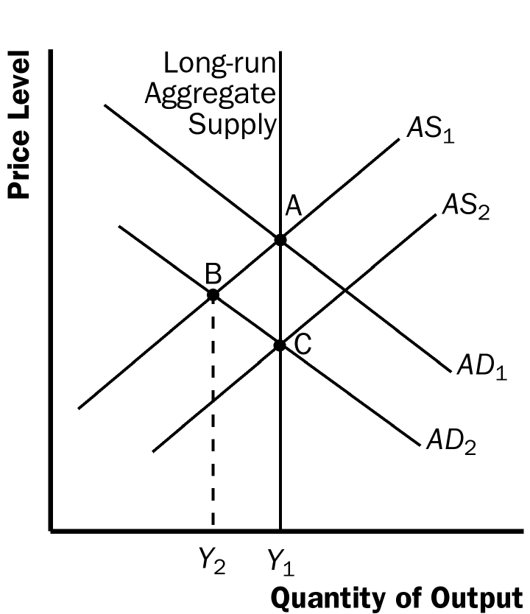

Figure 1

2. It is difficult for policymakers to choose the appropriate strength of their actions because of lags between when policy is changed and when it affects aggregate demand, as well as the difficulty in forecasting the economy's future condition. It is also difficult to anticipate how sensitive consumers and firms will be to the changes in policy.

3. a. If investors believe that capital taxes will remain low, then a reduction in capital taxes leads to increased investment.

b. After the increase in investment has occurred, the government has an incentive to renege on its policy because it can get more tax revenue by increasing taxes on the higher income from the larger capital stock.

c. Given the government's obvious incentive to renege on its promise, firms will be reluctant to increase investment when the government reduces tax rates. The government can increase the credibility of its tax change by somehow committing to low future tax rates. For example, it could write a law that guarantees low future tax rates for all capital income from investments made within the next year, or write a law penalizing itself if it raises future taxes.

d. This situation is similar to the time-inconsistency problem facing monetary policymakers because the government's incentives change over time. In both cases, the policymaker has an incentive to tell people one thing, then to do another once people have made an economic decision. For example, in the case of monetary policy, policymakers could announce an intention to lower inflation (so firms and workers will enter labor contracts with lower nominal wages), and policymakers could increase inflation to reduce real wages and stimulate the economy.

4. Issues about whether the costs of inflation are large or small are positive statements, as is the question about the size of the costs of reducing inflation. But the question of whether the Fed should reduce inflation to zero is a normative question.

5. The benefits of reducing inflation are permanent and the costs are temporary. Figure 2 illustrates this. The economy starts at point A. To reduce inflation, the Fed uses contractionary policy to move the economy down the short-run Phillips curve SRPC₁. Inflation declines and unemployment rises, so there are costs to reducing inflation. But the costs are only temporary, because the short-run Phillips curve eventually shifts to the left to SRPC₂, and the economy ends up at point B. Because inflation is lower at point B than at point A, and point B is on the long-run Phillips curve, the benefits of reducing inflation are permanent.

The costs of increasing inflation are permanent and the benefits are temporary for similar reasons. Again, suppose the economy starts at point A. To increase inflation, the Fed uses expansionary policy to move the economy up the short-run Phillips curve SRPC₁. Inflation rises and unemployment declines, so there are benefits to increasing inflation. But the benefits are only temporary, because the short-run Phillips curve eventually shifts to the right to SRPC₃, and the economy ends up at point C. Because inflation is higher at point C than at point A, and point C is on the long-run Phillips curve, the costs of increasing inflation are permanent.

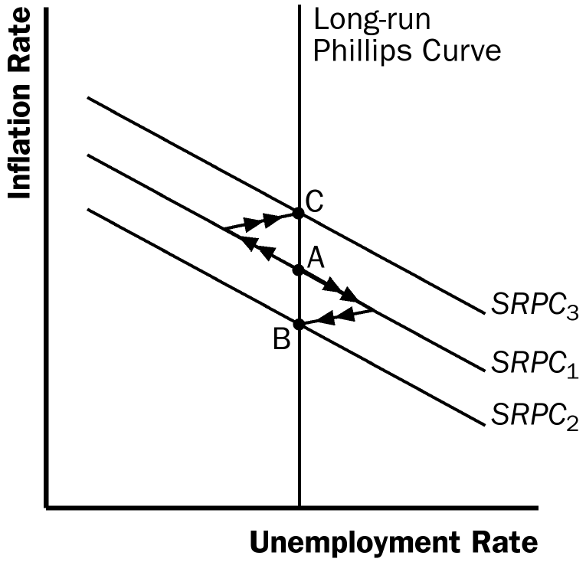

Figure 2

6. If the budget deficit is 12% of GDP and nominal GDP is rising 5% each year, the ratio of government debt to GDP will rise until it hits a fairly high level. (That level turns out to be debt/income = 12/5, because at that point, a deficit that is 12% of GDP with GDP growing 5% maintains the debt/income ratio at exactly 12/5. To be sustainable, debt and GDP must grow at the same rate, 5% each year. If the deficit is 12% of GDP, which is growing 5% each year, the ratio of debt to GDP must be 12/5, so that the deficit can be both 12% of GDP and maintain a constant ratio of debt to GDP.) Such a high debt level is likely to require a big tax increase on future generations. To keep future generations from having to pay such high taxes, you could increase your savings today and leave a bequest to them.

7. a. An increase in the budget deficit redistributes income from young to old, because future generations will have to pay higher taxes and will have a lower capital stock.

b. More generous subsidies for education loans redistribute income from old to young, because future generations benefit from having higher human capital.

c. Greater investments in highways and bridges redistribute income from old to young, because future generations benefit from having a higher level of public capital than otherwise.

d. An increase in Social Security benefits redistributes income from young to old, because current workers fund the benefits of those retired.

8. The fundamental trade-off that society faces if it chooses to save more is that it will have to reduce its consumption. Thus, society can consume less today and save more if it wants higher future income and consumption. The choice is really one of consumption today versus consumption in the future. The government can increase national saving by revising tax laws or by reducing its budget deficit.

